Tuscarora Township

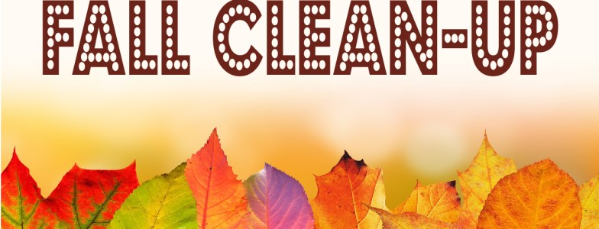
Will be holding their Fall Cleanup on October 1st from 7:00 am – 2:00 pm at the Township Building.

The Fall Cleanup Day is to accept your larger items that your normal trash company will not take. i.e. furniture, mattresses and box spring, appliances and metal items, all items must be free of gas and oil.

There is an 8-tire limit for car tires per household. Additional car tires - $2.50; truck tires - $5.00; Tractor Tires - $10.00. All tires must be removed from rims.

NO ELECTRONICS WILL BE ACCEPTED!

Limit of 1 drop off per household. No household refuse will be accepted.

We have the right to refuse any non-allowable items. Tuscarora Township residents only.

*Additional volunteers to assist are always welcome.

If you have any questions, please contact the Township Office at 717.589.7911.

Thank you!

